## WMS Live Report

URL: <http://liverpt.schenker.com.sg/Reports_I1/Pages/Folder.aspx?ItemPath=%2fVolkswagen&ViewMode=List>

Go to Folder: [Storage Utilization]

Reports:

S01_Chart_Historical Weekly Storage Utilization by Storage type

S02_Chart_Historical Weekly Storage Utilization by Bin Type

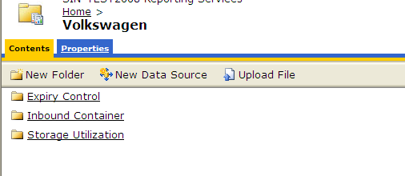

Sample report S01

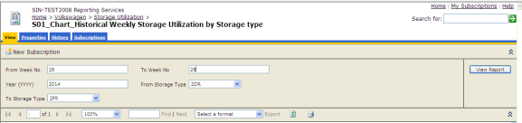

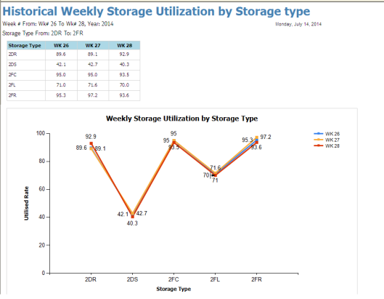

Sample Report S02 – by Bin type

